|  |  |  |
| --- | --- | --- |
| **EX.NO :04** | **Investigation of LAN – HTTP, DNS, DHCP, TELNET** | **REG.NO: URK22AI1015** |
| **DATE:16 -08 -2023** |

# AIM

To design a network topology to perform the initial router configurations required for connectivity by using static IP addresses. To configure DNS and investigate the working of DNS and HTTP. Dynamically obtain IP addresses using DHCP protocol and configure VTYto remotely access the router from PC using TELNET.

# DESCRIPTION

**HTTP:** Hypertext Transfer Protocol, is a versatile and stateless communication protocol that can be extended for various purposes through the addition of custom request methods, error codes, and headers. It operates over the TCP/IP framework and serves as the backbone for transmitting data across the World Wide Web.

**DNS:** Domain Name System, functions as the internet's name service, converting user-friendly domain names into numerical Internet Protocol (IP) addresses.

**DHCP:** Dynamic Host Configuration Protocol, operates as a client/server protocol, automating the assignment of an Internet Protocol (IP) address and distributing other essential configuration details like subnet masks and default gateways to IP hosts.

**TELNET:** Telnet serves as a network protocol employed for virtual computer access, facilitating a two-way, text-based communication channel between machines. It operates on the User Command Transmission Control Protocol/Internet Protocol (TCP/IP) networking standard for establishing remote sessions.

# PROCEDURE (DNS)

1. Click ‘Services’ in Server
2. Select ‘DNS’ from the panel
3. Give a name (www.colab.edu) and IP address of the server
4. Click ‘add’
5. Put the DNS address in the IP configuration tab of the end device
6. To access it ,click on ‘web browser’ on any end device and type the name assigned in the URL

# PROCEDURE (DHCP)

1. Click ‘DHCP’ from the ‘Services’ In ‘Server’
2. Enable it
3. Give its default gateway
4. Give the DNS Server address of the DNS server
5. Give range and click ‘add’
6. To access it click on any end devices
7. In IP configuration enable DHCP

# PROCEDURE (TELNET)

1. In the CLI of the router give the commands
2. Assign router password
3. Assign vty passwords
4. Open command prompt of the remote end device
5. Type telnet and gateway address of the router
6. Type the password and you can access the router via the remote end devices

# TELENT COMANDS

Router(config)# en password 1606 Router(config)#exit Router(config)#line vty 04

Router(config)#password 16062005 Router(config)#login

# TOPOLOGY DIAGRAM

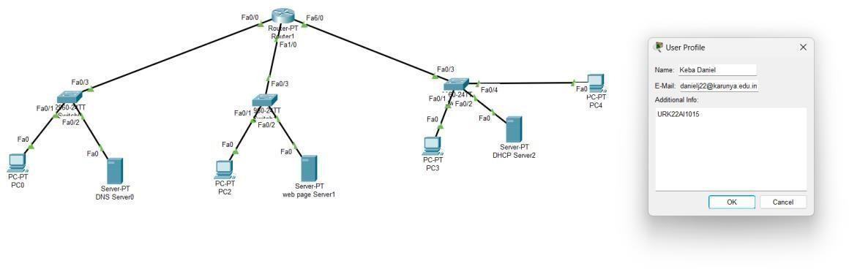

**ADDRESSING TABLE**

|  |  |  |  |  |
| --- | --- | --- | --- | --- |
| **Device** | **Interface** | **IP Address** | **Subnet Mask** | **Default Gateway** |
| **R1** | **Fa0/0** | **192.168.1.1** | **255.255.255.0** | NA |
| **Fa1/0** | **192.168.2.1** | **255.255.255.0** | NA |
| **Fa6/0** | **192.168.3.1** | **255.255.255.0** | NA |
| **PC1** | **NIC** | **192.168.1.2** | **255.255.255.0** | **192.168.1.1** |
| **Server** | **vty** | **192.168.1.3** | **255.255.255.0** | **192.168.1.1** |
| **PC2** | **NIC** | **192.168.2.2** | **255.255.255.0** | **192.168.2.1** |
| **Server 2** | **vty** | **192.168.2.3** | **255.255.255.0** | **192.168.2.1** |
| **PC3** | **NIC** | **192.168.3.2** | **255.255.255.0** | **192.168.3.1** |
| **Lap** | **NIC** | **192.168.3.3** | **255.255.255.0** | **192.168.3.1** |

# OUTPUT

**Screenshot of static IP address for any 1 PC**

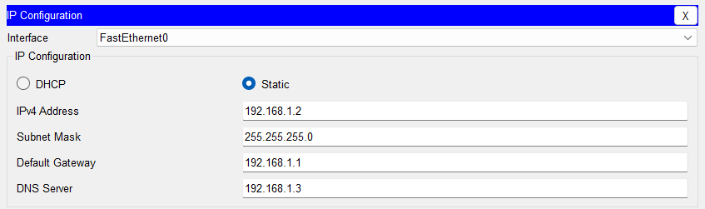

# Screenshot of DNS settings

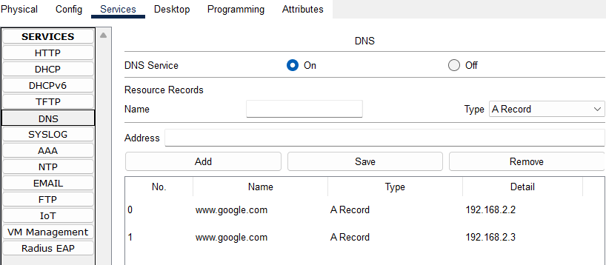

**Screenshot of access to Web server**

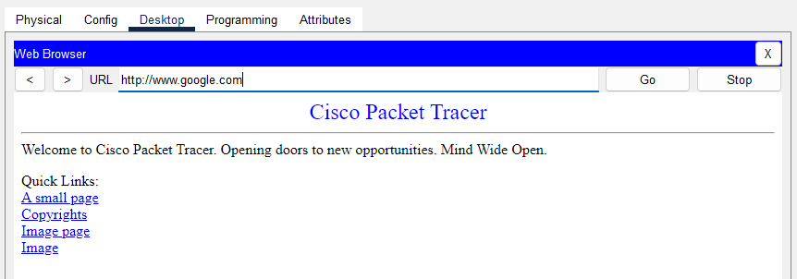

# Screenshot of DHCP settings

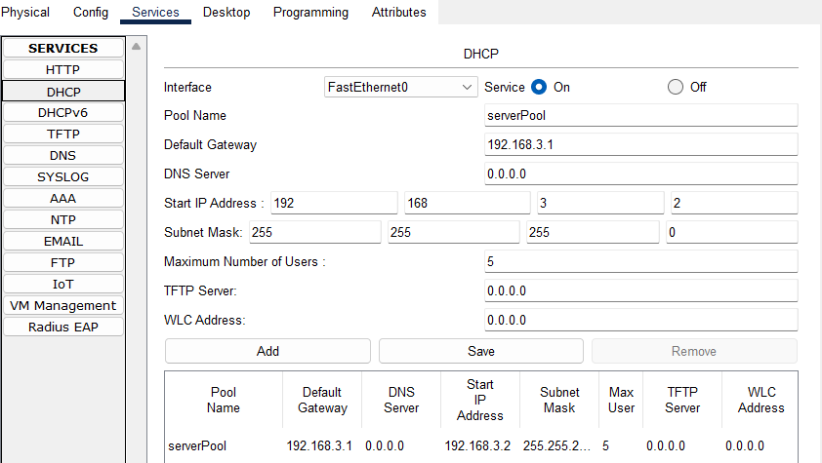

**Screenshot of DHCP IP address for any 1 PC**

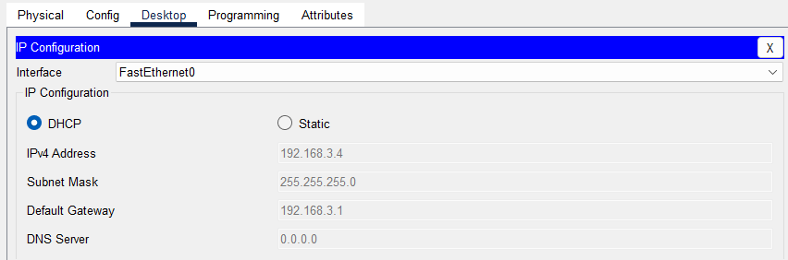

# Screenshot of running-config file with VTY

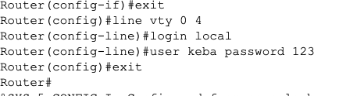

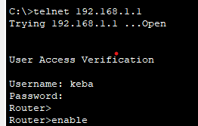**Screenshot of successful ping from 1 PC to any 1 remote host. Screenshot of successful TELNET access (from CMD)**

# Screenshot of Routing Table of router

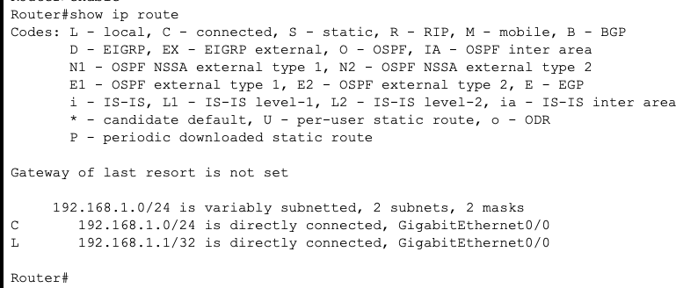

**Screenshot of successful ping from 1 PC to any 1 remote host.**

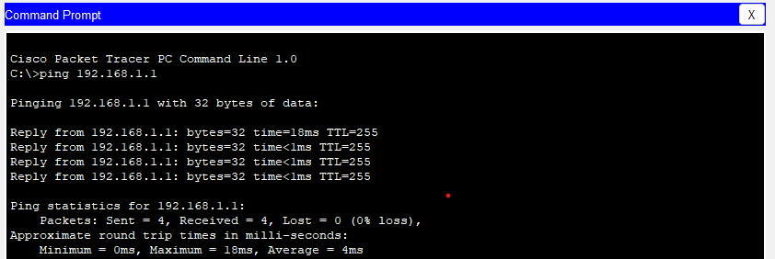

# RESULT:

The required configuration of DNS and investigate the working of DNS and HTTP with the help of above mentioned steps and method.